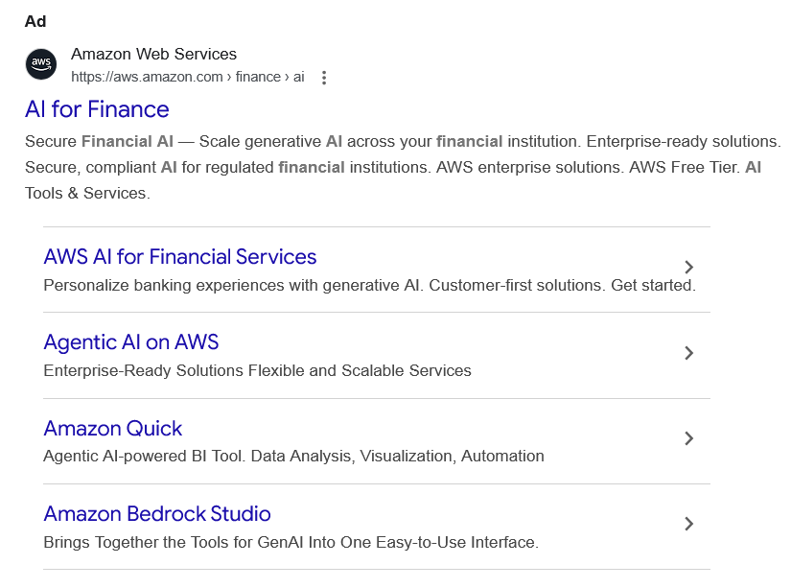
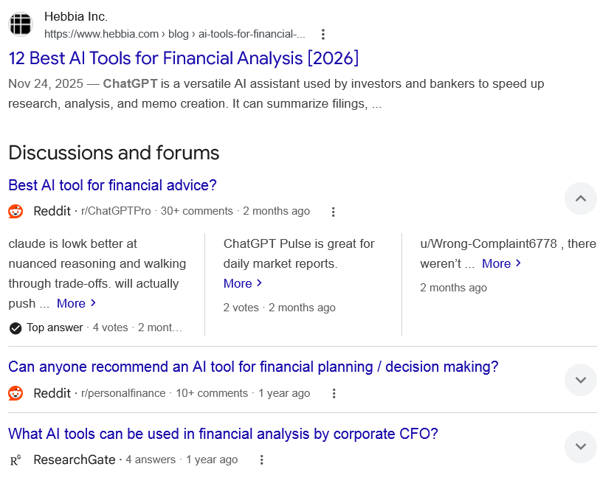

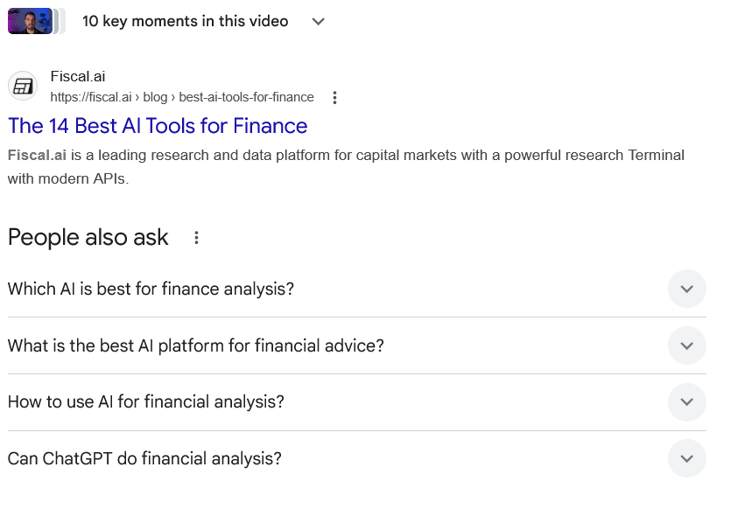
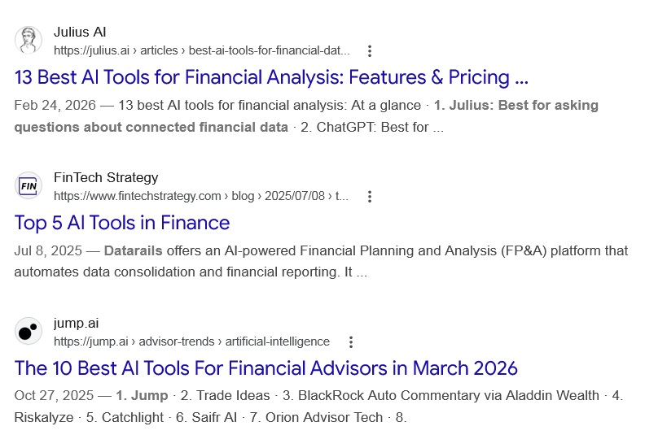
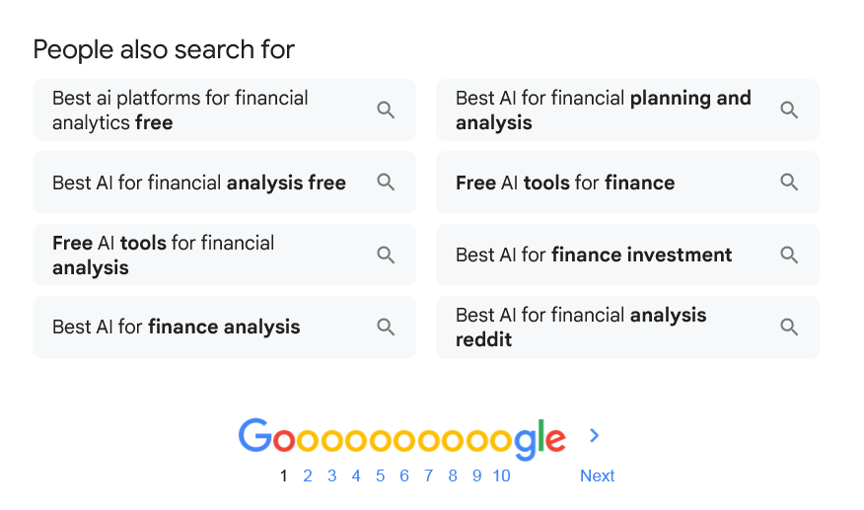
Ad

AI for Finance
Amazon Web Services
https://aws.amazon.com › finance › ai

Amazon Web Services
https://aws.amazon.com › finance › ai

My Ad Centre
Secure Financial AI — Scale generative AI across your financial institution. Enterprise-ready solutions. Secure, compliant AI for regulated financial institutions. AWS enterprise solutions. AWS Free Tier. AI Tools & Services.

AWS AI for Financial Services
Personalize banking experiences with generative AI. Customer-first solutions. Get started.

Agentic AI on AWS
Enterprise-Ready Solutions Flexible and Scalable Services

Amazon Quick
Agentic AI-powered BI Tool. Data Analysis, Visualization, Automation

Amazon Bedrock Studio
Brings Together the Tools for GenAI Into One Easy-to-Use Interface.

People also search for

Web results

12 Best AI Tools for Financial Analysis [2026]

Hebbia Inc.
https://www.hebbia.com › blog › ai-tools-for-financial-...

Hebbia Inc.
https://www.hebbia.com › blog › ai-tools-for-financial-...
Nov 24, 2025 — ChatGPT is a versatile AI assistant used by investors and bankers to speed up research, analysis, and memo creation. It can summarize filings, ...
Discussions and forums

Best AI tool for financial advice?
Reddit ·
r/ChatGPTPro
· 30+ comments
· 2 months ago

Best AI tool for financial advice?
Reddit ·
r/ChatGPTPro
· 30+ comments
· 2 months ago
claude is lowk better at nuanced reasoning and walking through trade-offs. will actually push ... More
Top answer · 4 votes · 2 months ago
ChatGPT Pulse is great for daily market reports. More
2 votes · 2 months ago
u/Wrong-Complaint6778 , there weren’t ... More
2 months ago

Can anyone recommend an AI tool for financial planning / decision making?
Reddit ·
r/personalfinance
· 10+ comments
· 1 year ago

Can anyone recommend an AI tool for financial planning / decision making?
Reddit ·
r/personalfinance
· 10+ comments
· 1 year ago
Best Financial Analysis Tools and Software for Smart Decision-Making ... Discover the AI-Powered Financial Analysis Platform. 0. 2. Are there ... More

What AI tools can be used in financial analysis by corporate CFO?
ResearchGate ·
4 answers
· 1 year ago

What AI tools can be used in financial analysis by corporate CFO?
ResearchGate ·
4 answers
· 1 year ago
Datarails – AI-powered financial reporting and forecasting for CFOs Power BI (Microsoft ... More
a year ago
Hasanain Faisal Shoman Here are some popular AI tools and platforms that can be particularly ... More
a year ago
Many Thanks More
a year ago

See more

Web results

Ranking the Best AI Tools for Financial Modeling (2026)

Wall Street Prep
https://www.wallstreetprep.com › knowledge › ranking-...

Wall Street Prep
https://www.wallstreetprep.com › knowledge › ranking-...
We ranked the top AI financial modeling tools: ChatGPT, Claude, Microsoft Copilot Agent Mode, and Shortcut using investment banking standards — here's what ...
•
Quick Answer: Which financial...

•
The AI financial modeling tools...

AI Tools for Finance: ChatGPT vs. Claude vs. Gemini

Corporate Finance Institute
https://corporatefinanceinstitute.com › Resources

Corporate Finance Institute
https://corporatefinanceinstitute.com › Resources
Jan 21, 2025 — Discover how AI tools like ChatGPT, Claude, and Gemini transform finance with powerful features for data analysis, modeling, reporting, ...

Best 10 AI Tools for Financial Service Professionals

DataSnipper
https://www.datasnipper.com › resources › top-artificial...

DataSnipper
https://www.datasnipper.com › resources › top-artificial...
Top AI finance tools include DataSnipper, Workiva, MindBridge, Datarails, Cube, Ramp, Brex, Validis, Power BI with Copilot, and Alteryx. Each supports different ...

Best AI Tools For Finance: 10X Your Productivity

YouTube · Bojan Radojicic
14.1K+ views · 5 months ago

YouTube · Bojan Radojicic
14.1K+ views · 5 months ago

20:01
In this video I'll walk you through nine AI platforms for finance professionals when to use each real examples integration with other apps.

10 key moments10 key moments in this video

From 00:00
Intro

From 00:50
ChatGPT

From 04:22
Gemini

From 06:37
Genspark

From 08:42
Perplexity

From 11:01
Grok

From 12:27
DeepSeek

From 14:23
Copilot

From 16:04
Claude

From 17:52
Fiscal AI

The 14 Best AI Tools for Finance

Fiscal.ai
https://fiscal.ai › blog › best-ai-tools-for-finance

Fiscal.ai
https://fiscal.ai › blog › best-ai-tools-for-finance
Fiscal.ai is a leading research and data platform for capital markets with a powerful research Terminal with modern APIs.
People also ask
Which AI is best for finance analysis?
Top AI finance tools include DataSnipper, Workiva, MindBridge, Datarails, Cube, Ramp, Brex, Validis, Power BI with Copilot, and Alteryx. Each supports different needs - from automation and anomaly detection to spend management and ESG reporting.

10+ Best AI Tools for Financial Service - DataSnipper

DataSnipper
https://www.datasnipper.com › resources › top-artificial...

DataSnipper
https://www.datasnipper.com › resources › top-artificial...
What is the best AI platform for financial advice?
CNBC Select previously recommended Betterment and Monarch for their automated investing and budgeting tools. We also like Cleo for its AI chatbot, which provides spending insights and money management advice.Feb 4, 2026

AI-powered tools offer help with your financial planning — should you bite?

CNBC
https://www.cnbc.com › select › ai-powered-financial-pla...

CNBC
https://www.cnbc.com › select › ai-powered-financial-pla...
How to use AI for financial analysis?
5 Ways to Leverage AI for Financial Analysis
- Automate routine workflows.
- Use predictive analytics for better forecasting.
- Leverage real-time insights for analysis.
- Extract key insights from complex data.
- Simplify data analysis with AI-powered tools.
Mar 6, 2025

Top 5 Ways to Use AI for Financial Analysis - Workday Blog

Workday Blog
https://blog.workday.com › en-us › top-5-ways-leverage...

Workday Blog
https://blog.workday.com › en-us › top-5-ways-leverage...
Can ChatGPT do financial analysis?
ChatGPT can analyze financial data, including expenses and financial statements (income statement, balance sheet, and cash flow statement). ChatGPT will discern anomalies in the data requiring human investigation and follow-up. Finance can determine the accuracy of any financial analysis created by ChatGPT.Dec 26, 2025

14 Best Ways to Use ChatGPT for Finance - Tipalti

Tipalti
https://tipalti.com › blog › chatgpt-for-finance

Tipalti
https://tipalti.com › blog › chatgpt-for-finance

Web results

13 Best AI Tools for Financial Analysis: Features & Pricing ...

Julius AI
https://julius.ai › articles › best-ai-tools-for-financial-dat...

Julius AI
https://julius.ai › articles › best-ai-tools-for-financial-dat...
Feb 24, 2026 — 13 best AI tools for financial analysis: At a glance · 1. Julius: Best for asking questions about connected financial data · 2. ChatGPT: Best for ...

Top 5 AI Tools in Finance

FinTech Strategy
https://www.fintechstrategy.com › blog › 2025/07/08 › t...

FinTech Strategy
https://www.fintechstrategy.com › blog › 2025/07/08 › t...
Jul 8, 2025 — Datarails offers an AI-powered Financial Planning and Analysis (FP&A) platform that automates data consolidation and financial reporting. It ...

The 10 Best AI Tools For Financial Advisors in March 2026

jump.ai
https://jump.ai › advisor-trends › artificial-intelligence

jump.ai
https://jump.ai › advisor-trends › artificial-intelligence
Oct 27, 2025 — 1. Jump · 2. Trade Ideas · 3. BlackRock Auto Commentary via Aladdin Wealth · 4. Riskalyze · 5. Catchlight · 6. Saifr AI · 7. Orion Advisor Tech · 8.
People also search for

Best ai platforms for financial analytics free

Best AI for financial analysis free

Free AI tools for financial analysis

Best AI for finance analysis

Best AI for financial planning and analysis

Free AI tools for finance

Best AI for finance investment

Best AI for financial analysis reddit

Page navigation
 | 1 | 2 | 3 | 4 | 5 | 6 | 7 | 8 | 9 | 10 | Next

